**Task Description#1**

* Zero-shot: Prompt AI to write a function that checks whether a given year is a leap year.

**Expected Output#1**

* AI-generated function with no examples provided

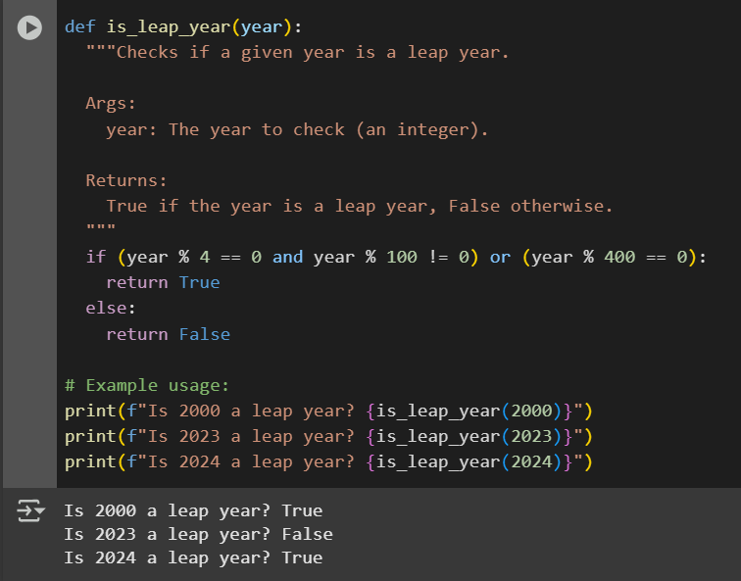

Observation: Google collab gave the correct code to identity the leap years by the function is_leap_year.It helps to identify the year.Abd the code is simple to understand. By dividing year 4 and 100 and 400

**Task Description#2**

* One-shot: Give one input-output example to guide AI in writing a function that converts centimeters to inches.

**Expected Output#2**

Function with correct conversion logic

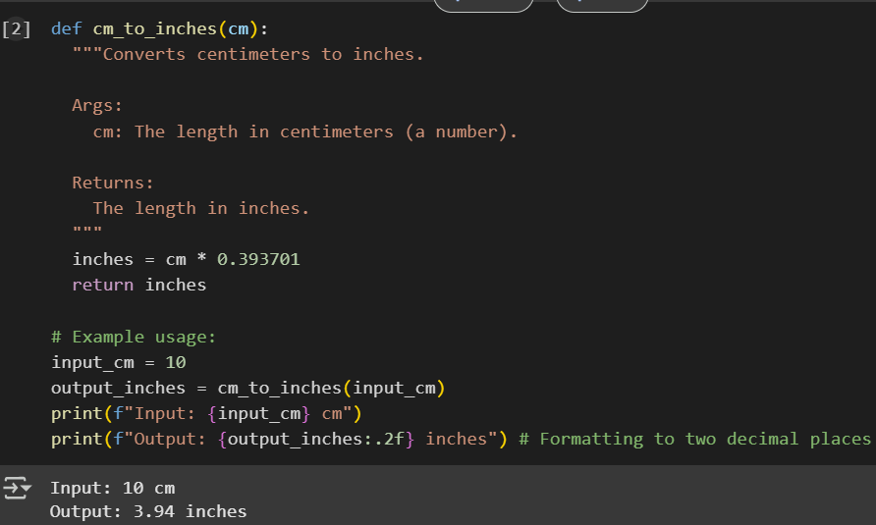

Observation: Function cm_to_inches converting the values without any error.By giving one example.It is very easy code by multiplying the cm by 0.3993701. So it gives the value of inches.In Google collab

**Task Description#3**

* Few-shot: Provide 2–3 examples to generate a function that formats full names as “Last, First”.

**Expected Output#3**

* Well-structured function respecting the examples

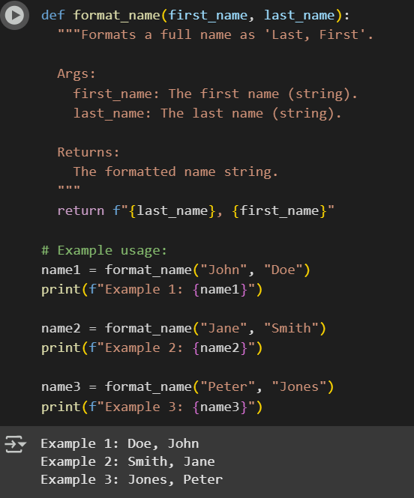

Observation: In Google Collab.It gave a Function format_name. clearly gave well -structured code and examples to it. It arranges the last name and first name by dividing by “ , ”.

**Task Description#4**

* Compare zero-shot and few-shot prompts for writing a function that counts the number of vowels in a string.

**Expected Output#4**

* Functional output and comparative reflection

Observation:

|  |  |
| --- | --- |
| **ZERO SHOT** | **FEW SHOT** |
|  |  |
| Observation:In Google Collab it gave the code finding the about the finding no of vowels.by single example | Observation: It gave few more examples in Google collab |

**Task Description#5**

* Use few-shot prompting to generate a function that reads a .txt file and returns the number of lines.

**Expected Output#5**

* Working file-processing function with AI-guided logic

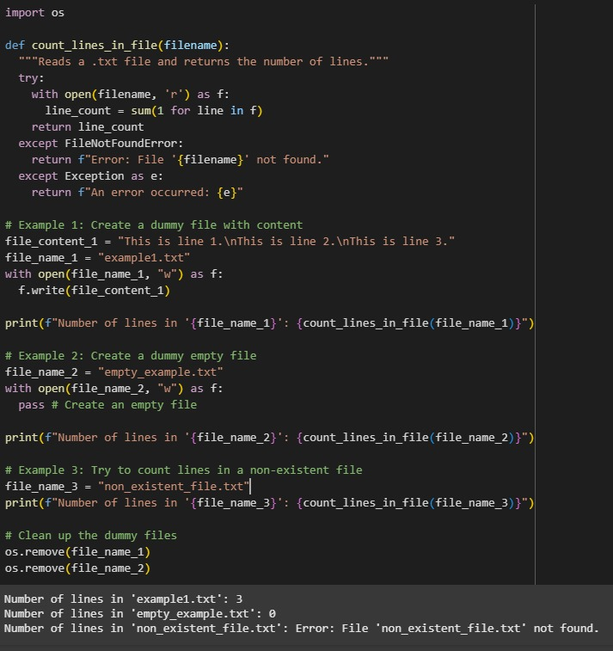

Observation: In Google Collab function works correctly and counts lines in a text file.Output is correct in all test cases. Code is clean and easy to read.